Project Name -Specifications Document

Project overview.
Short description of the DUT.
Explain:
- Purpose of component
- Intended functionality
- The role of this component in a digital system
- General operating principle
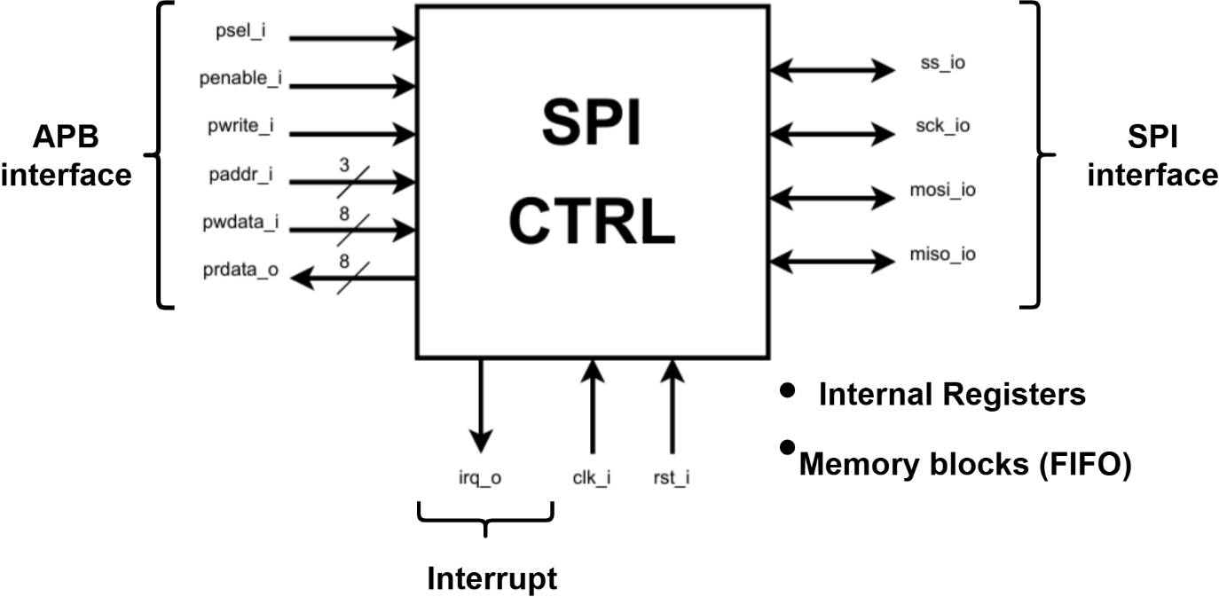
Figure of the DUT.
Define the functionality included in the current implementation.
Specify any functionality that is intentionally excluded.
List relevant refrences and what was used in studying.

Interface specification
Decribe all external signals and interfaces of the DUT.
List of the requirements from the specification with each of their identifiers.
  - Clock and reset signals:
Signal | Direction | Width | Description
clk_i | Input | 1 | Clock signal
rst_i | input | 1 | Reset signal

Specify:
- Clock edge used for operation
- Reset polarity
- Syncrhonous or asynchronous reset
- Reset assertion and reset deassertion behavior
Include a table of reset values.
Reg/Signal | Reset value | Description
reg_1 | 0
signal_1_i | 0

  - Input signals:
Signal | Width | Description
input_1_i
input_1_i

Describe the purpose and expected behavior of each input.

  - Output signals:
Signal | Width | Description
output_1_o
output_2_o

Describe the purpose and expected behavior of each output.

  - Interface behavior:
- Signal dependencies
- Handshake requirements
- Data transfer protocol
- Valid operating conditions
- Timing requirements

Parameters and configuration.
  - List of all configurable parameters of the DUT
Parameter | Default value | Description | Constraints
DATA_WIDTH | 8 | Data bus width | Greater than 0
DEPTH | 16 | Storage depth | Greater than 0

Explain how changing the parameters affects the DUT.

Functional requirements.
List all of the requirements of the DUT.
Each requirements must have a unique identifier and describe one specific, clearly defined behavior.
- REQ-001: The DUT shall clear its internal state when reset is asserted.
- REQ-002: The DUT shall accept input data when write enable signal is asserted.
- REQ-003: The DUT shall maintain its current state when the enable signal is asserted.
- Etc.

Operational behavior.
Explain how the DUT operates under different conditions.
  - Normal operation
Sequence of operations and relationships between inputs, internal state and outputs for normal operations.
  - Boundary conditions
Describe the expected behavior at the limits of the DUT’s operating range.
- Minimum and maximum counter values
- First and last memory addresses
- Empty and full FIFO conditions
- Minimum and maximum supported data widths

  - Simultaneous operations
Describe the DUT when multiple operations occur at the same time.
- Simultaneous read and write
- Multiple active requrests
- Reset during active operation
- Input updates during ongoing transaction

  - Illegal or unsupported operations
Describe inputs and operation sequences that are outside the supported operating conditions.
Specify the expected DUT behavior, such as:
- Ignoring the operation
- Maintining the previous state
- Returning error indicator
- Entering defined recovery state

  - Error conditions
Describe possible error conditions and how the DUT should respond.
- Invalid addresses
- Invalid commands
- Protocol violations
- Overflow or underflow
- Invalid state transitions

Timing specification.
Describe the timing requirements of the DUT.
Include:
- Clocking behavior
- Input sampling conditions
- Output update conditions
- Operation latency
- Minimum and maximum respone times
- Handshake timing
- Data stability requirements

  - Latency and throughput
- Number of clock cycles for an operation
- Whether operations can overlap
- Maximum supported transaction rate
- Wehther b2b transactions are supported

  - Timing diagrams
Include timing diagrams illustrating the expected behavior for important operations.
- Reset sequence
- Read operation
- Write operation
- Req/Ack sequence
- Data transfer

Design constraints.
  - Design constraints
- Supported data widths
- Maximum storage depth
- Supported clock frequency
- Supported protocol configurations

Specification summary (can be moved to the beginning).
Summarize the main characteristics of the DUT.
Characteristic | Description
Component type
Clock domains
Reset type

Revision history.
Version | Date | Description of changes
1.0 |  | Initial specification

